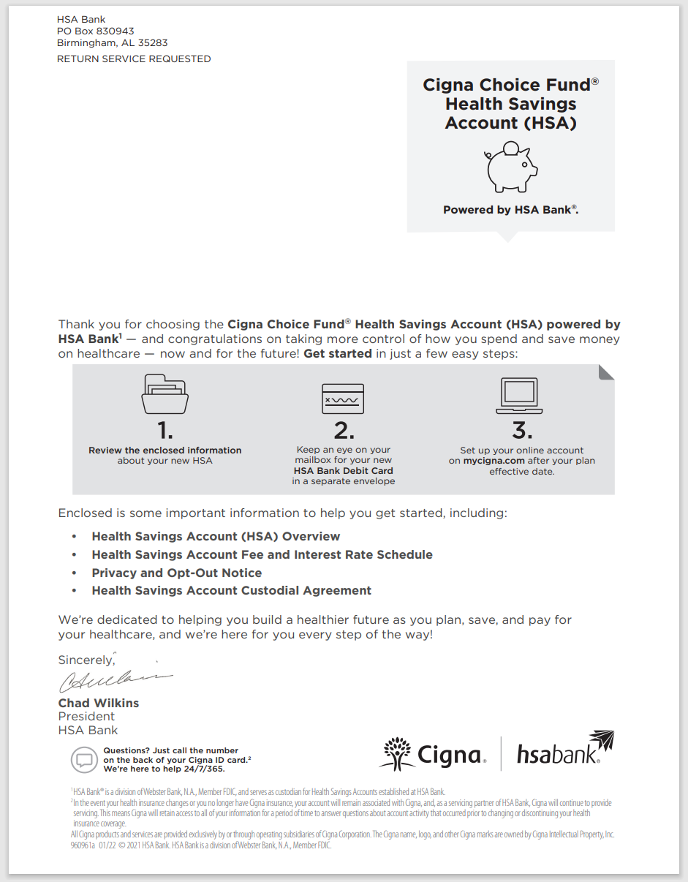

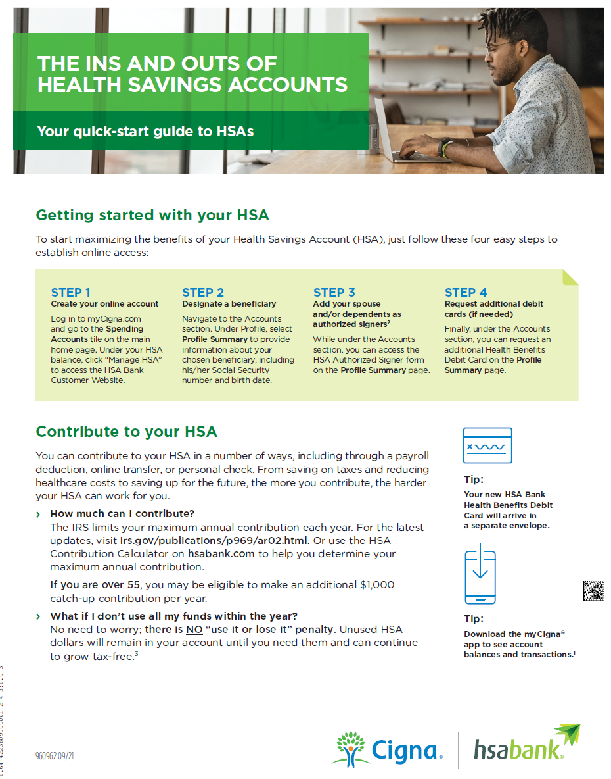
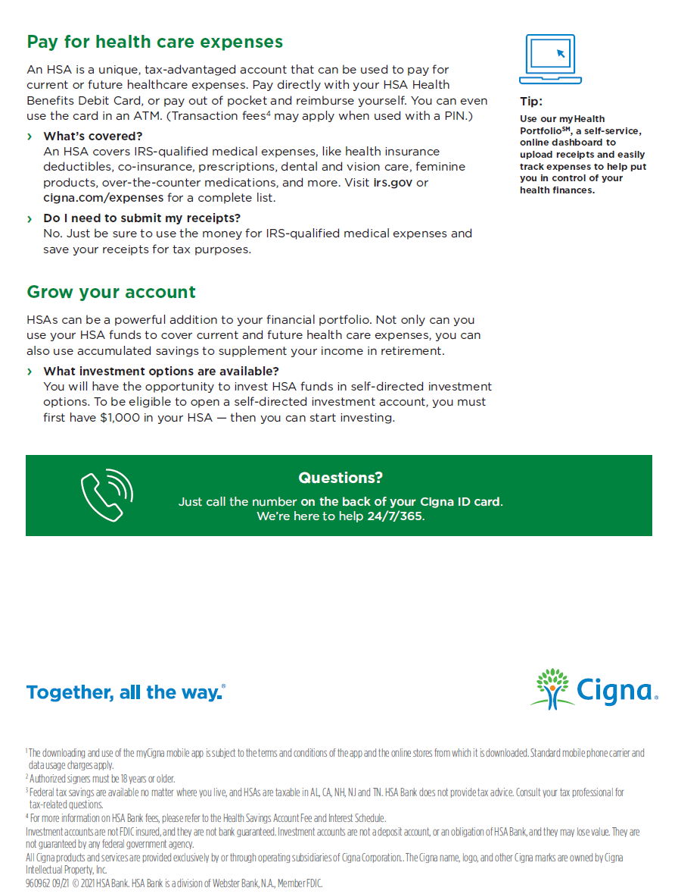

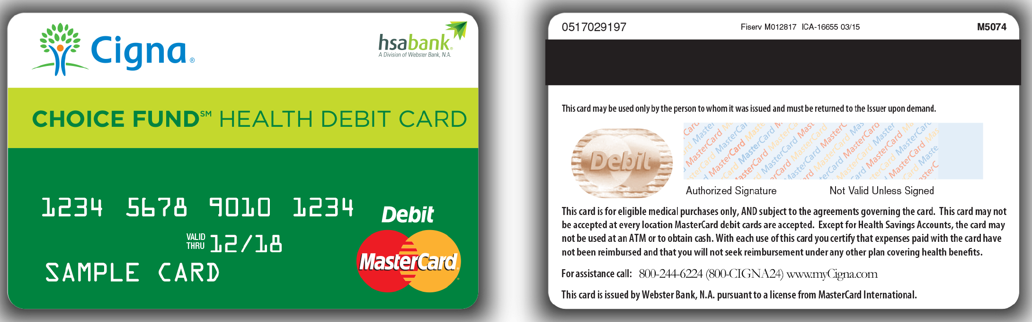

Confidential, unpublished property of Cigna. Do not duplicate or distribute. Use and distribution limited solely to authorized personnel. © Copyright 2022 Cigna.

